**ACTIVITY :25 INDUSTRIAL TOUR 05-03-2022**

**OBJECTIVE :** The objective of an industrial visit is to provide students an insite into the corporate world . It provides students with a practical real world perspective on different functions. Today , we all perfectly understand that theoretical knowledge is just not enough for a successful professional career with an aim to go beyond academics , industrial visit provides students a practical perspective on the world of work .

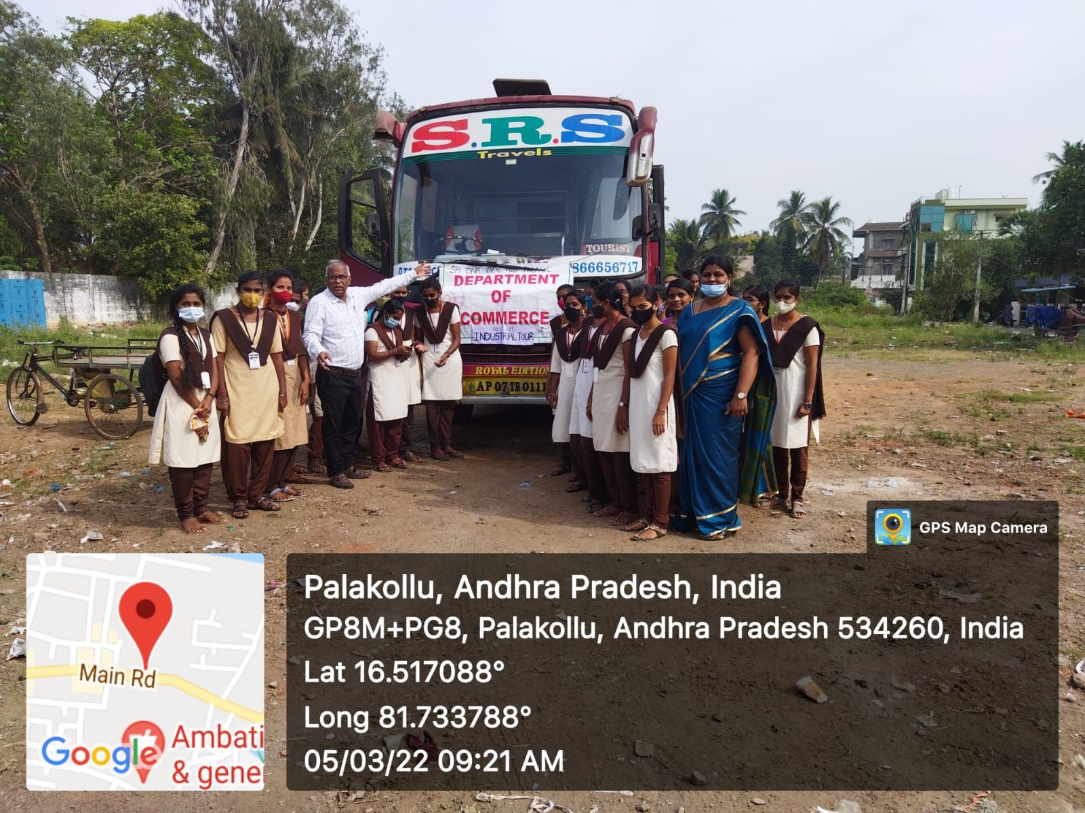

**DESCRIPTION :** Industrial visit helps students to combine the theoretical knowledge of the business operations with the practical knowledge of its actual functioning .

Visited “KONASEEMA AGRO PRODUCTS” which was located at mummidivaram . The industry which prepares extra virgin coconut oil which has more benefits for health .

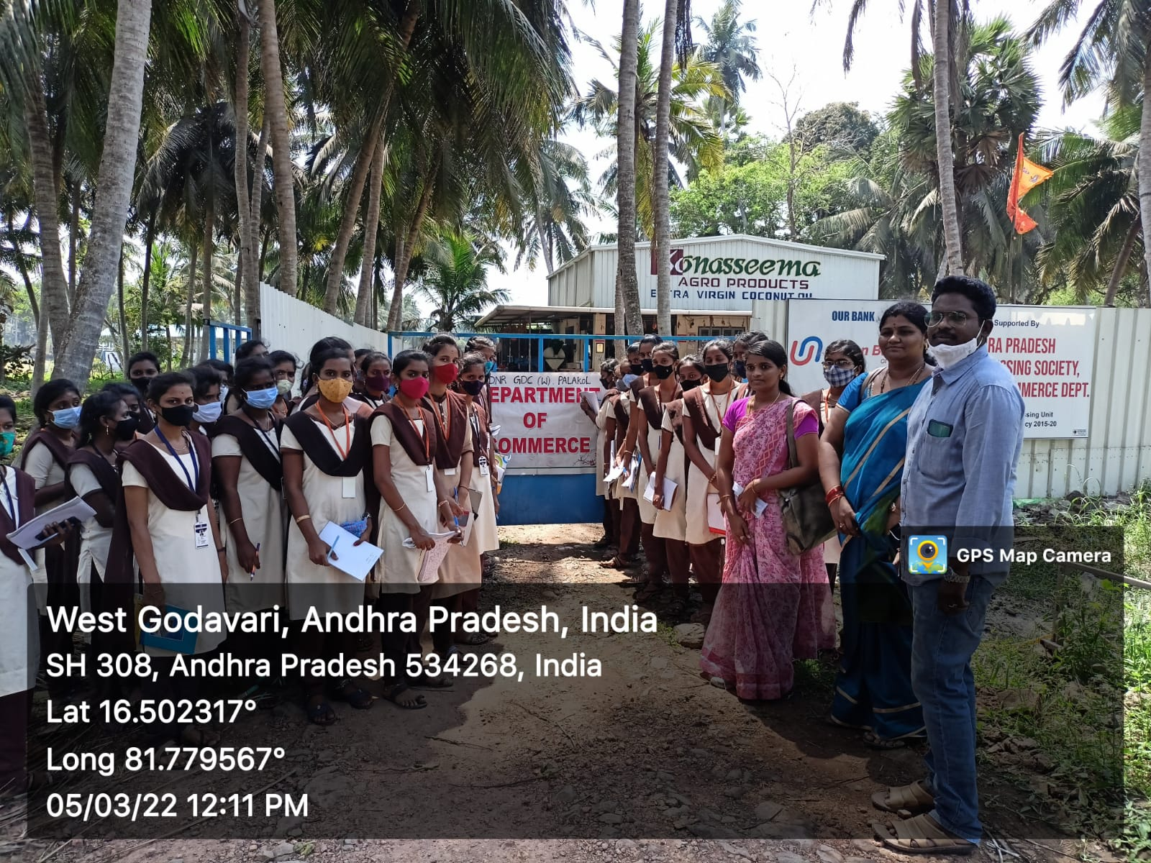

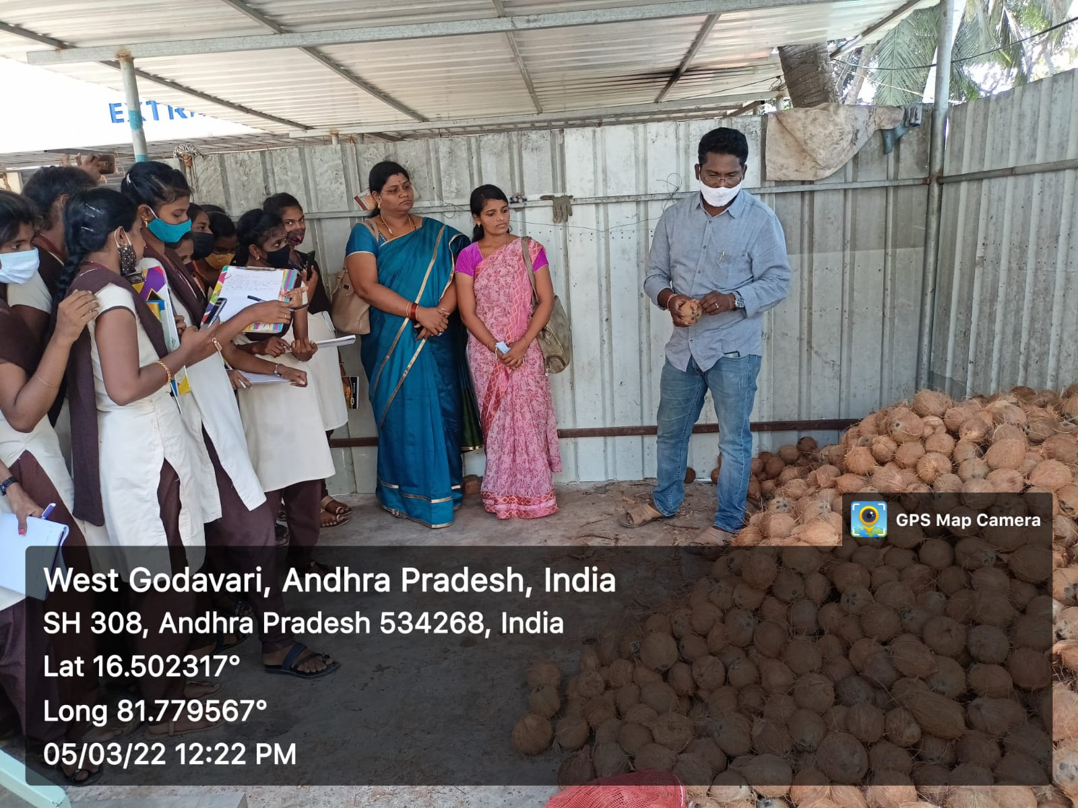

**OUTCOME** : This industrial tour provides the students an opportunity to learn practically through interaction , working methods and employment practices. It gives the students an exposure to current work practices are as opposed to theoretical knowledge taught at college .

**NO. OF STUDENTS : 60**

**NO. OF LECTURERS: 2**